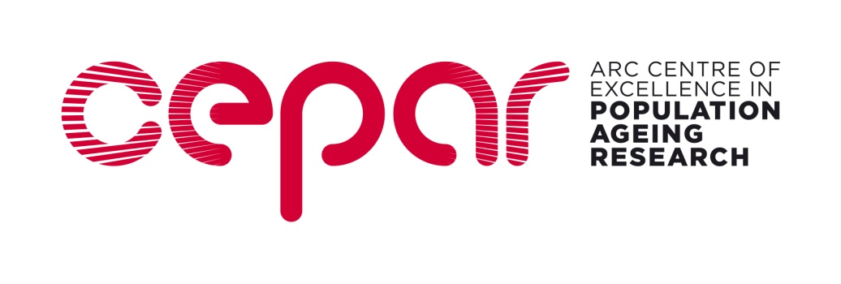

ECR WORKSHOP 2022
Application to participate in a two-day workshop and Travel Bursary Application

Please complete and return to a.brushwood@unsw.edu.au by 11 November 2022
ALL PARTICIPANTS
Name: | Title:
Email address: | Phone number:
Please provide details of any dietary requirements you may have (lunch and morning and afternoon tea are all included in the workshop package):
Please state briefly how this workshop will benefit your research development (approx 200 words):

State your experience with quantitative data analysis (include any experience with (1) multilevel models, also known as mixed models/mixed-effects models/hierarchical linear models/random-effects models, (2) any kind of longitudinal data analysis, and (3) with and RStudio):

Describe the dataset/s you will be analysing with skills acquired at this workshop:

I understand that I am required to bring my own laptop with installed statistical software (R and RStudio) and daily diary/experience sampling datasets that I am working with. Please note that you are not required to provide your own dataset if you do not have one available right now: an example dataset will be provided, so you can still fully participate without your own data.
Please list which longitudinal methods courses you have previously attended (eg ACSPRI, HILDA, CEPAR etc):

EARLY CAREER RESEARCHERS* | PHD STUDENTS
Current role and location (department and institution) e.g., Lecturer, School of Psychology, UNSW: | Location (department and institution):
Previous qualifications  (degree, discipline, institution and year of award e.g., PhD Psychology UNSW, 2009): | Current degree program and first year of enrolment (e.g., PhD Psychology, 2010):
Research interests: | Thesis topic:  Name of supervisor:
TRAVEL BURSARY APPLICANTS ONLY
A number of travel bursaries are available to successful workshop applicants from interstate to assist with travel and accommodation costs. Successful applicants will be reimbursed up to the value of $750 on presentation of receipts for eligible items. Reimbursements are made directly to the participant’s bank accounts. If you wish to be considered for a travel bursary please complete details below.

Residential address:

Bank details:

Account name:

BSB:

Account Number:

Bank name:

Branch:

CERTIFICATION
I have attached my CV

I understand that it is a requirement of registration that I am available to attend both days of the workshop.

Signature: Date:

* (The ARC defines Early Career Researchers as researchers who are within five years of the start of their research careers. This normally means that you have been awarded a PhD or equivalent research doctorate within five years, however, an extension to this limit may be approved owing to significant career interruptions.)

